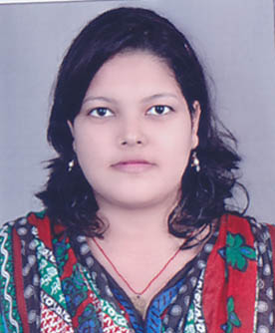
RESUME

Email id:monalishababy65@gmail.com  Mobile : +919658386334, | Present Address:-  Cuttack; Odisha

Career Objective
“Looking forward for a carrier in an organization/company where I can use my technical skills, efforts and knowledge for the growth of the organization & my personal enhancement”

Professional Qualification

Graduation in Physics

Educational Qualifications
Year | Board/University | Degree/Examination | Percentage
2012-2015 | Utkal University | DEGREE(First class with distinction)In Physics | 73.3
20010-2012  2010 | CHSE  HSCE | +2 Science  10th | 71.33  85.5

Work experience
Content Writer at Khuntia digital marketing Pvt. Ltd.

Computer Knowledge
PGDCA

Points for Self
- Social by nature and friendly with everybody.
- Systematic Hard Working & Time Conscious Determined.
- Smile in typical situation
Hobbies
- Surfing Internet
- Listening Music &watching movie
- Gardening
- Reading magazines

Personal Details
Date of Birth : | 06/05/1995
Father’s Name : | Bishnu Ch. Biswal
Marital Status : | Unmarried
Gender : | female
Language Known : | English, Hindi, odiya
Permanent Address : | AT:PANASPUR  PO:RAHANIA  VIA:KUANPAL  DIST:CUTTACK(ODISHA)  PIN-754204

Declaration
I hereby all the declare information provided above is true to the best of my knowledge and belief.
Date: 18/06/2016.

